Description | With the FIFA World Cup 2026 approaching, a promotional image has been circulated online as part of the opening campaign. It looks clean, polished, and entirely ordinary—just another piece of media hype.  Still, something about the file feels… off.  If you take a closer look beyond the surface, you might find that it holds more than just pixels. Sometimes, what’s left behind tells a different story than what’s meant to be seen.  (Flag should be entered in all as lowercase; ex RCCTF{seattle})
Files | WorldCup2026.jpg
Hint(s) | What? There’s a file in a file!

Walkthrough | Open the image in a hex editor (like HxD). You can search for the hex value “50 4B 03 04”. Click the first result (a little after the header signature, you will see “[Content_Types].xml”).  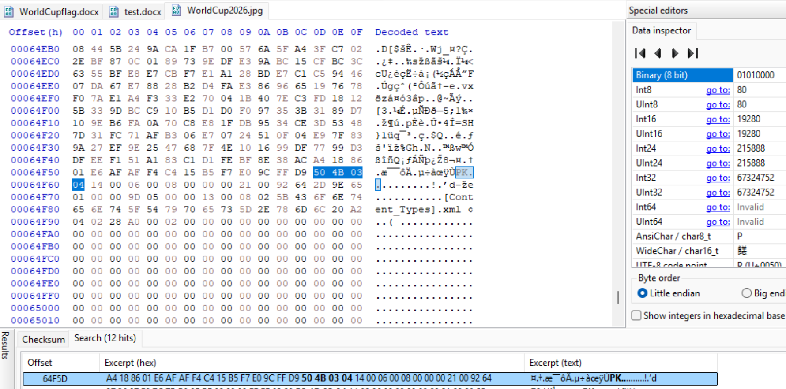  Copy the hex values from the header signature to the end of the file. Then add them to a new file. Save it as a .docx file.  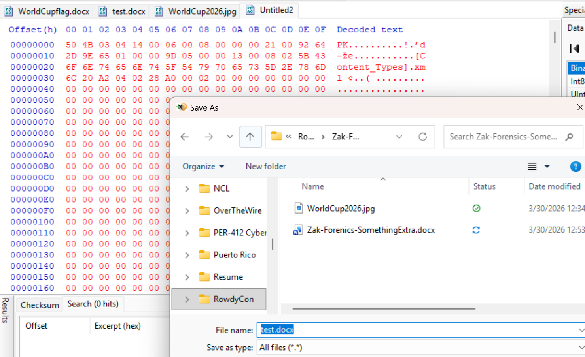  Then open the new .docx file to find the flag.
Flag | RCCTF{I_w0nder_if_yamal_is_go1ng_to_show_a_madness} - Lower Case

